**ASSIGNMEMT 2**

**SECONDHOPE**

**01st March 2018**

**Janki Rathod (0864129)**

**Krima Patel (0859652)**

**Mohana Santhosh Reddy (0688824)**

**PROJECT DESCRIPTION –**

* The main aim of this project is to reduce the gap between the surrogates and parents.

**PROJECT FEATURE -**

Second Hope, we have three modules –

* Surrogate Module –
* If a person chooses to become a Surrogate, she can fill up the application form online, which includes various details on her personal data, health information.
* A surrogate needs to be healthy enough and also she should satisfy all the medical conditions and concerned government laws before taking any responsibility.
* Intended Parents Module –
* Parents will get a list of available surrogates, among the available, the Intended Parents can choose surrogate.
* Parents can consult with doctor to get some idea about surrogate and surrogacy process.
* Doctor Module –
* Doctors will give approval to surrogate after verifying and checking all details from the application form and all the health related reports, which were submitted during the application.

Below is the Use Case Diagram of Second Hope–

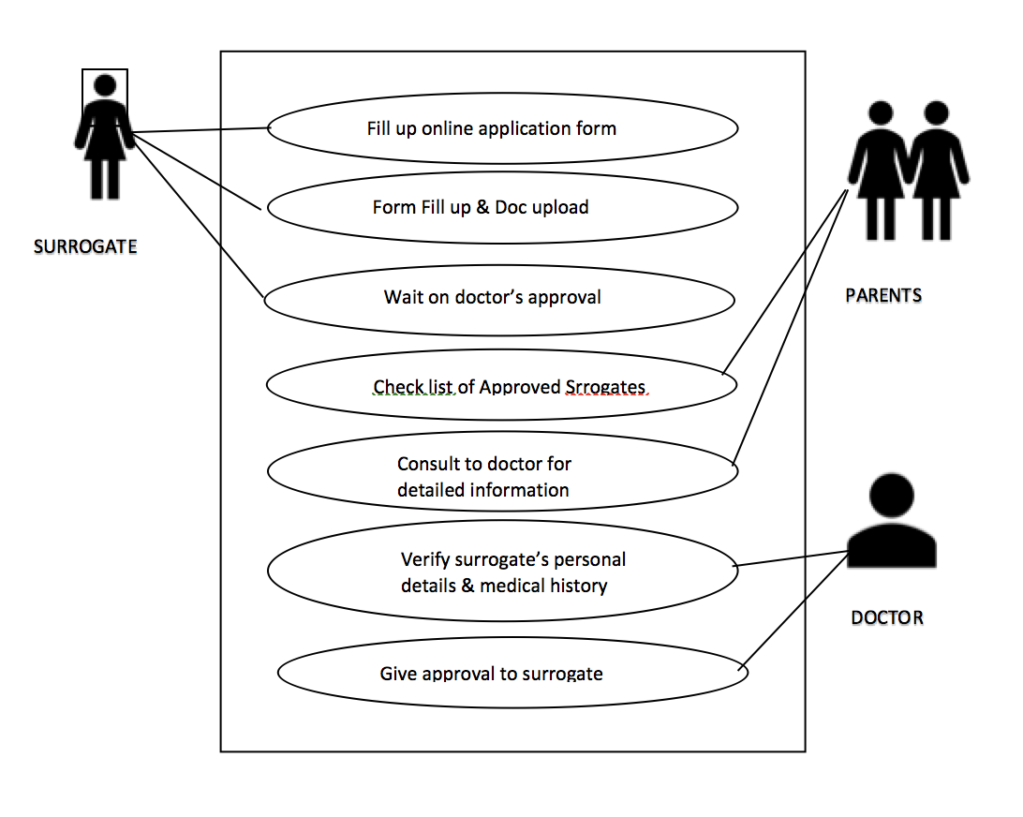

**PROJECT FEATURES IMPLEMENTED –**

**BACK END – Surrogate Module**

**DATABASE – SURROGATE**

We have developed 19 Database Tables and 11 Stored Procedures.

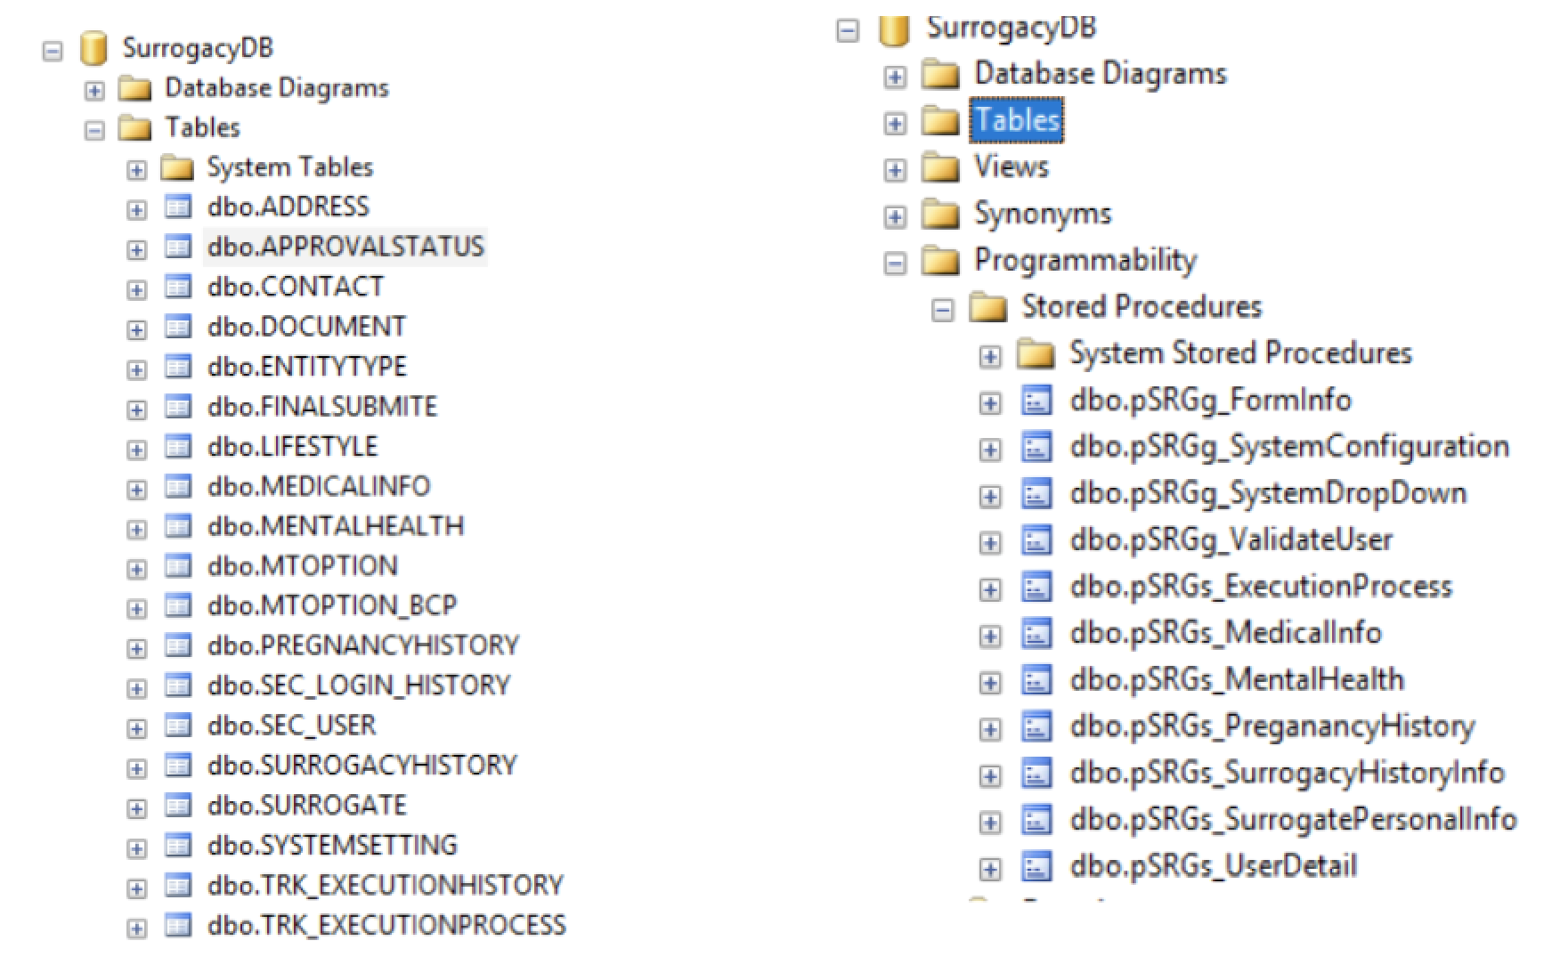

**FRONT END – Surrogate Module**

**USER ACCOUNT –**

A Login page is created for the existing user credentials.

If you’re not an existing client (Surrogate and Intended Parent), then you can register yourself as a New Member using the Register as New Membership tab.

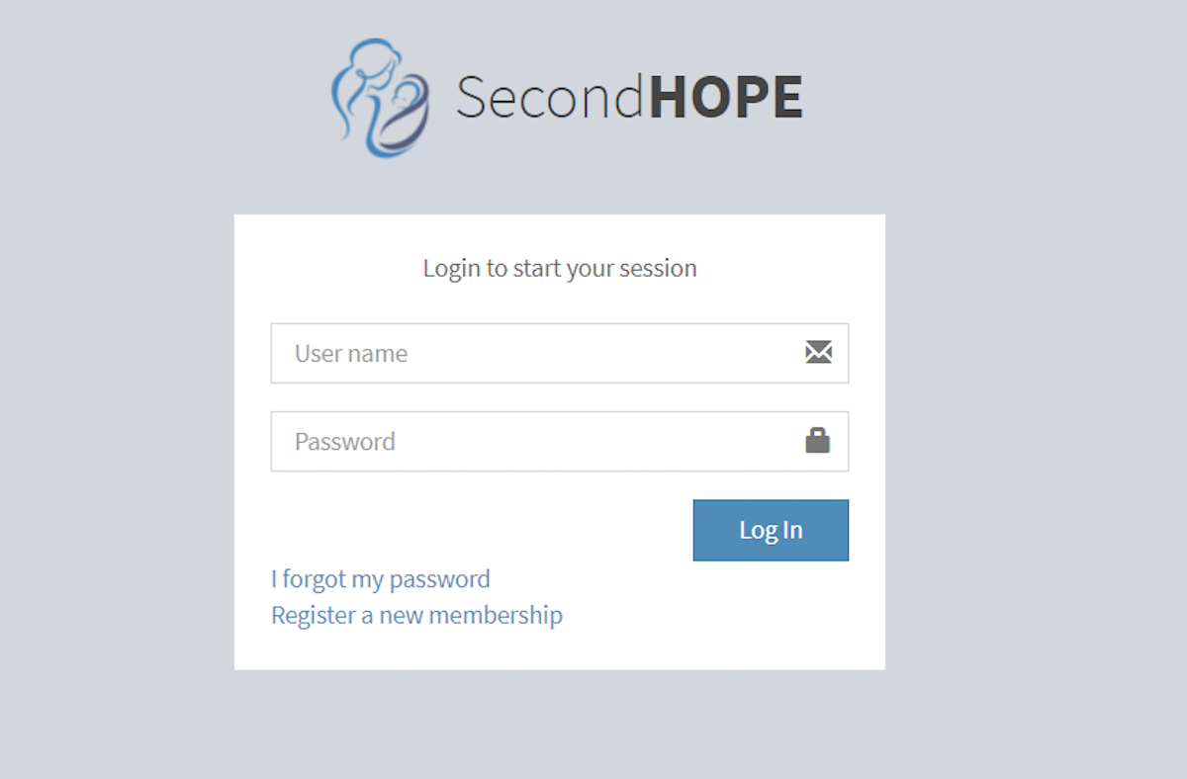

In the Register as New Member, we have declared the below fields which are mandatory and need to be filled by Surrogate or Intended Parent. In the last field before Register, we have given the slot to choose between Surrogate and Intended Parent. This Registration is only for Surrogate and Intended Parents.

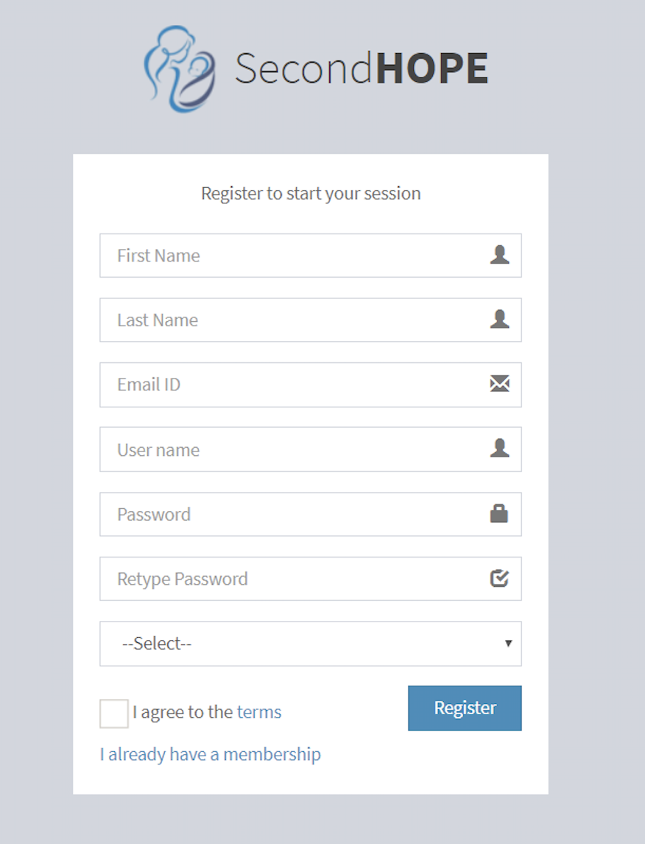

**SURROGATE – DASHBOARD**

In the Surrogate Dashboard, we have a **Form Progress Tab**, which displays on going status of the started application. The blue colour bar, displays how many numbers of forms has been submitted and remaining to be completed.

In the **Form Submission and Approval Status** – The Number field displays the number of forms, which has to been completed by the Surrogate in order to enrol as on of the Surrogate Mothers.

The **Forms** field displays, the details of types of forms that have to been filled in by the Surrogate.

The **Status** field displays, the status of the respective form. **N/A** is been displayed, when all the forms has not been submitted. Once all forms are submitted, then the status will be changed to **Pending**, which means that the application has been forward for review purpose. When Doctor can approve or reject a particular application based on the eligibility criteria. The Status will be changed to **Approved**, when the applicant has been eligible based on all the medical records and other process else the Status will display **Rejected.**

In **Is Submitted?** which shows whether a particular form’s has been submitted or not. The surrogate can choose which form to fill in; there is no particular order that needs to be followed. But on constraint is that, all forms have to be submitted.

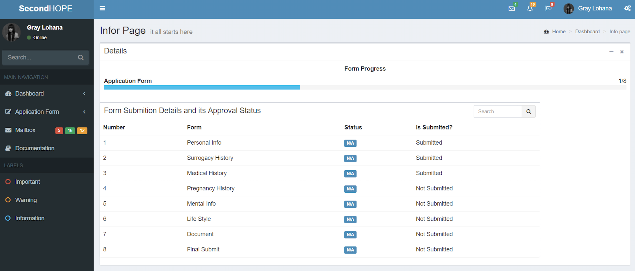

**SURROGATE – APPLICATION FORMS**

These are the types of forms that a surrogate mother needs to fill in, in order to become a surrogate.

PERSONAL INFORMATION

SURROGACY HISTORY

MEDICAL HISTORY

PREGNANCY HISTORY

MENTAL INFORMATION

LIFE STYLE

DOCUMENTATION

DISCLAIMER/FINAL SUBMIT

We have implemented only the first five forms so far.

**Personal Information**

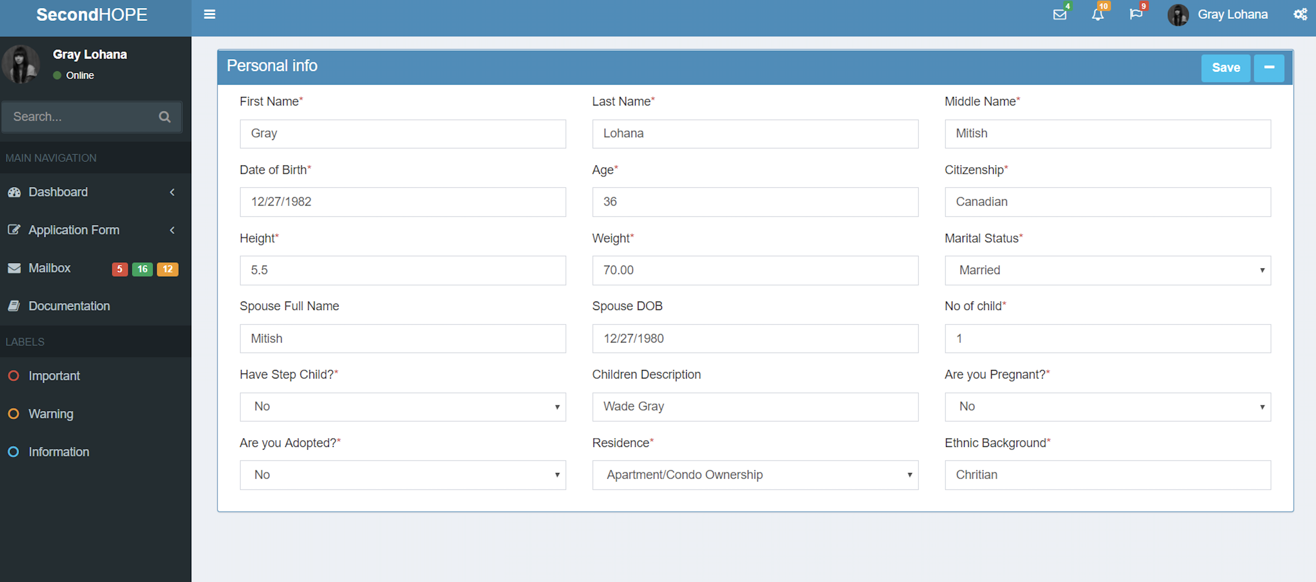

In this form, the Surrogate’s Basic information is been asked.

**Surrogacy History**

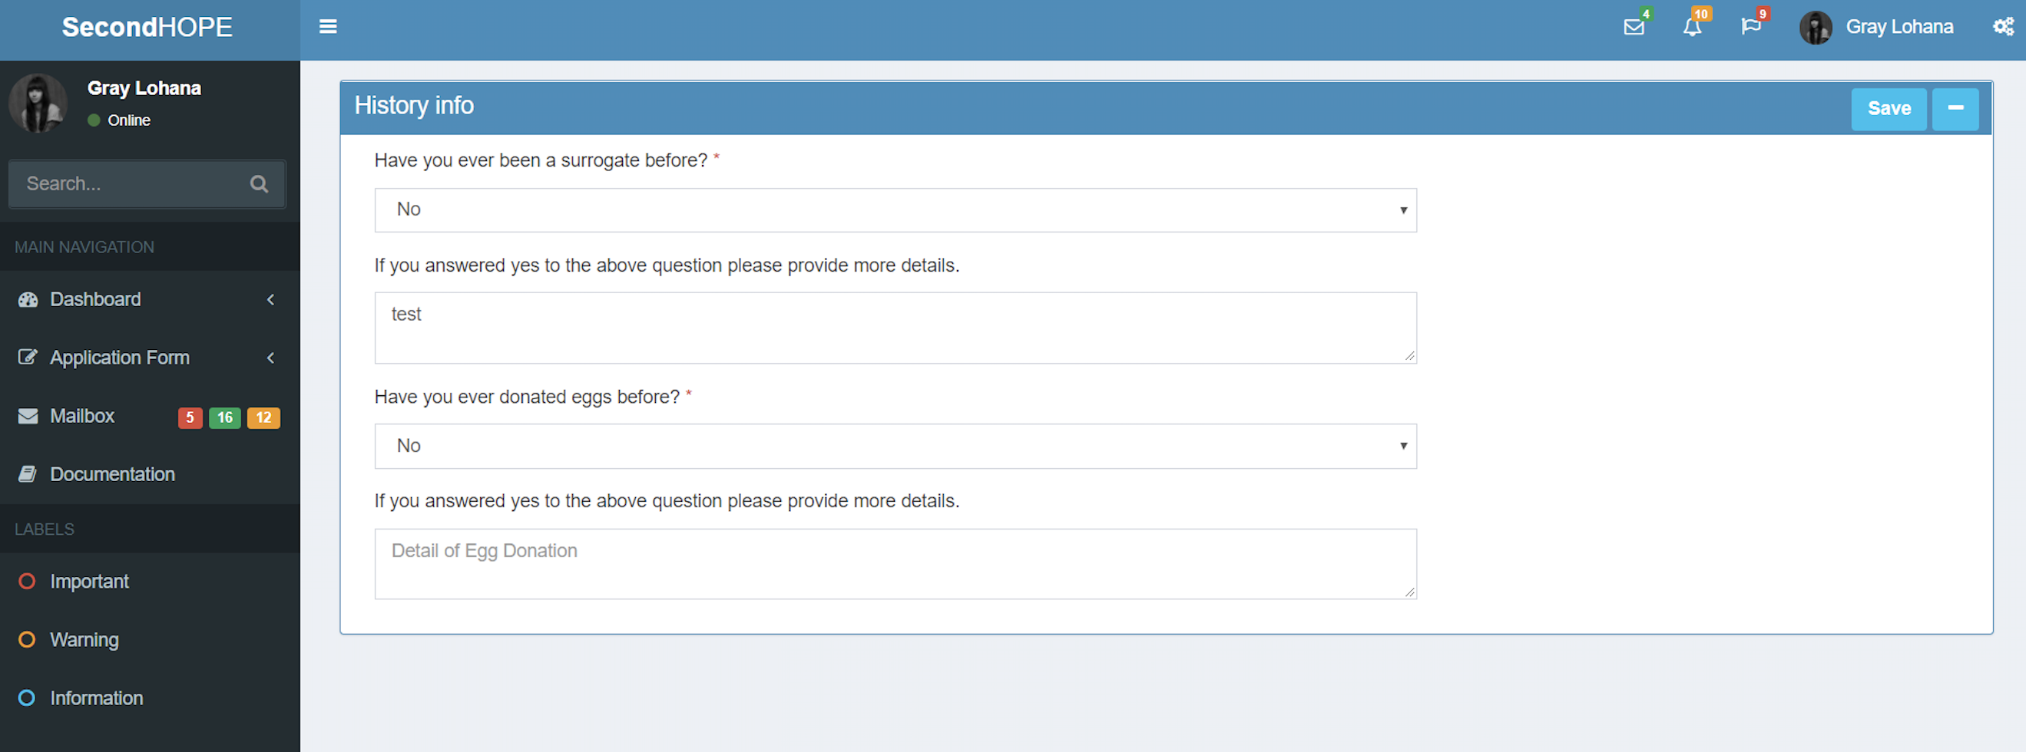

In this form, the details of the surrogate’s past history whether she has been a surrogate earlier in her life.

**Medical History**

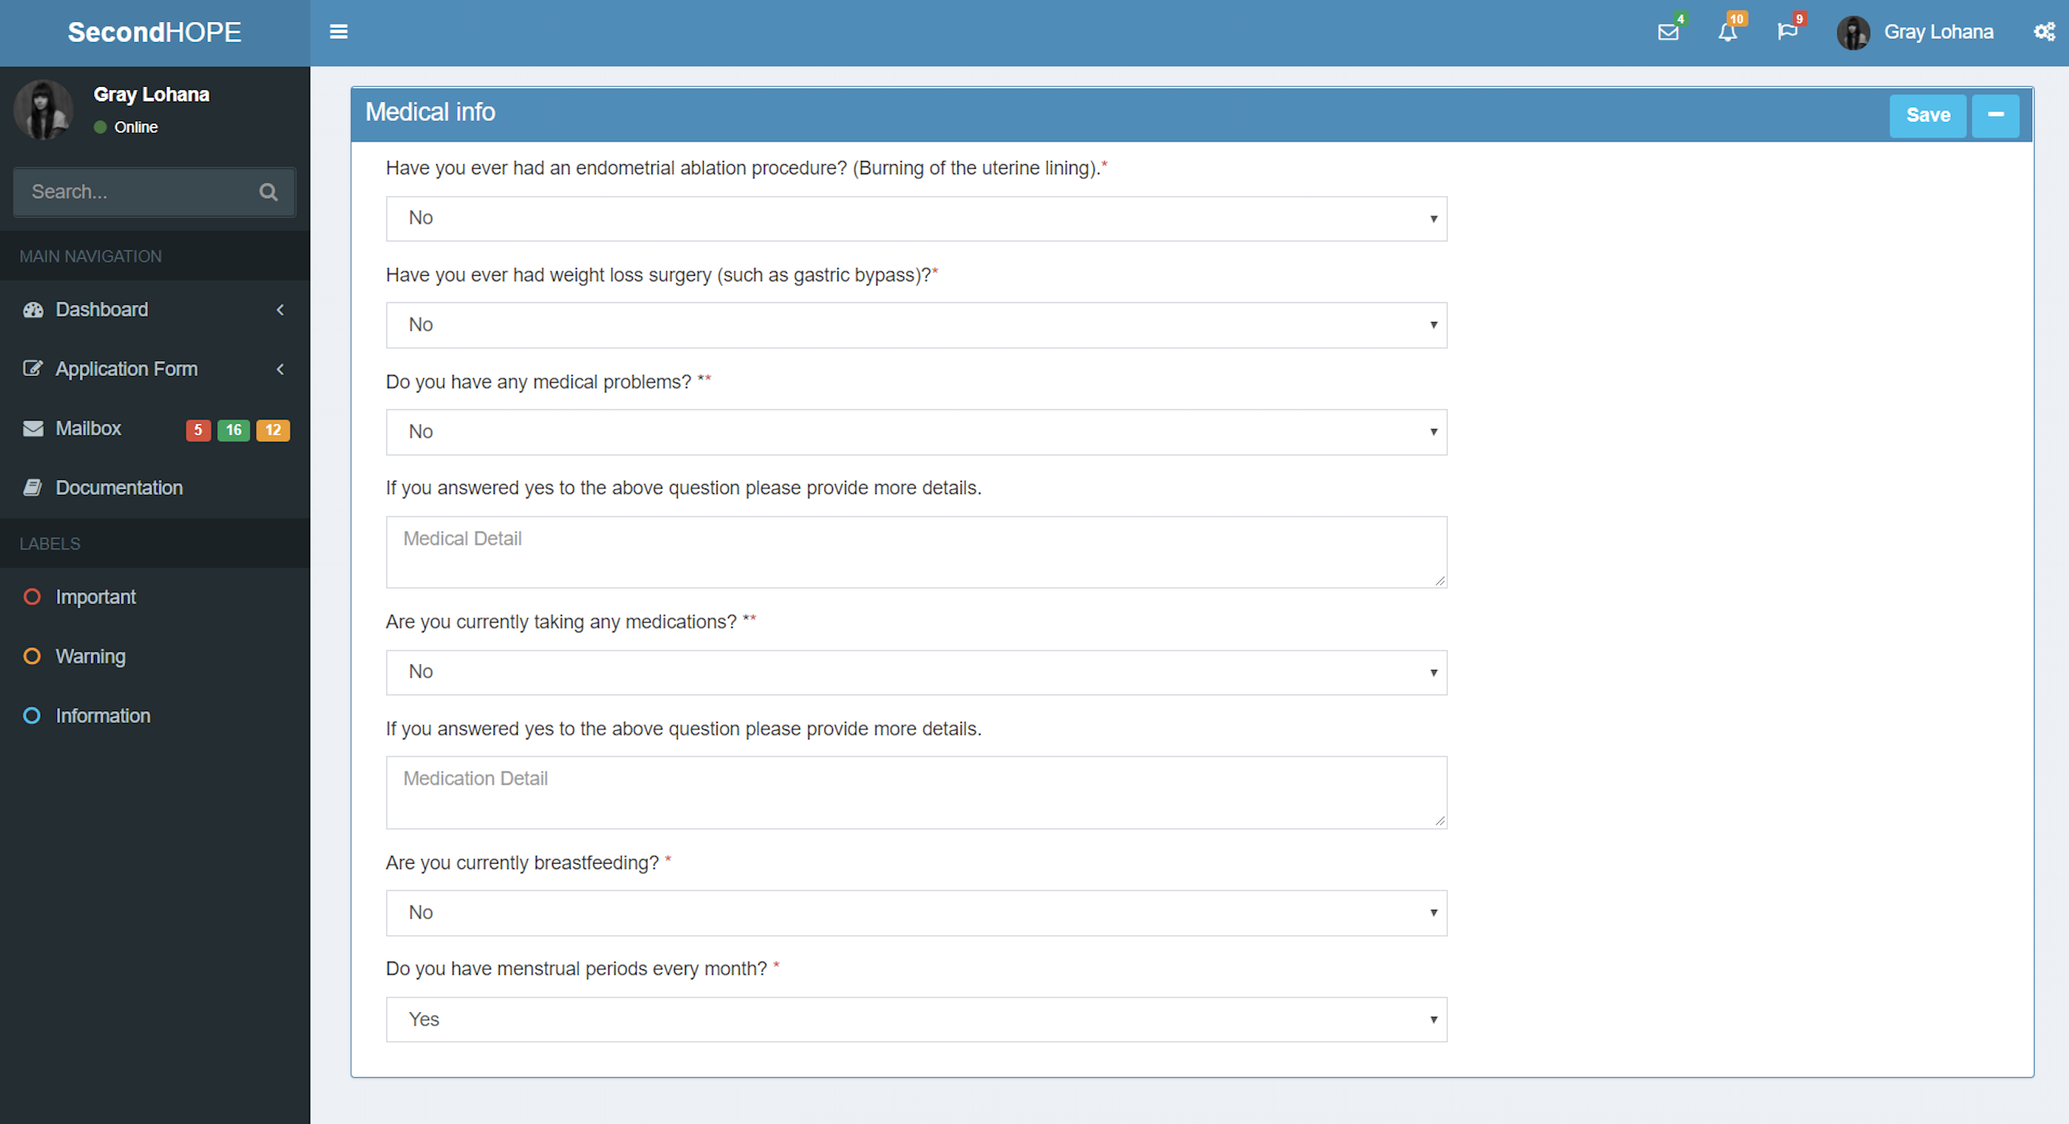

Here, we are asking for her other health related questions, which are interlinked for the process of surrogacy.

**Pregnancy History**

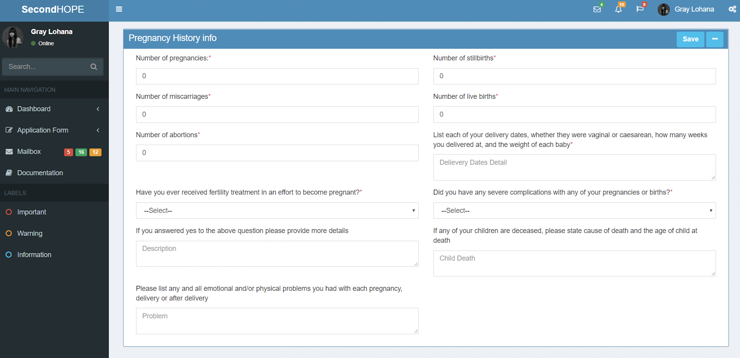

Here, the pregnancy delivery details of surrogate’s own pregnancy is been asked. If a person has to become a surrogate, she has to be at least given birth of her own once. So these questions play a pivot role in choosing a surrogate.

**Mental Information**

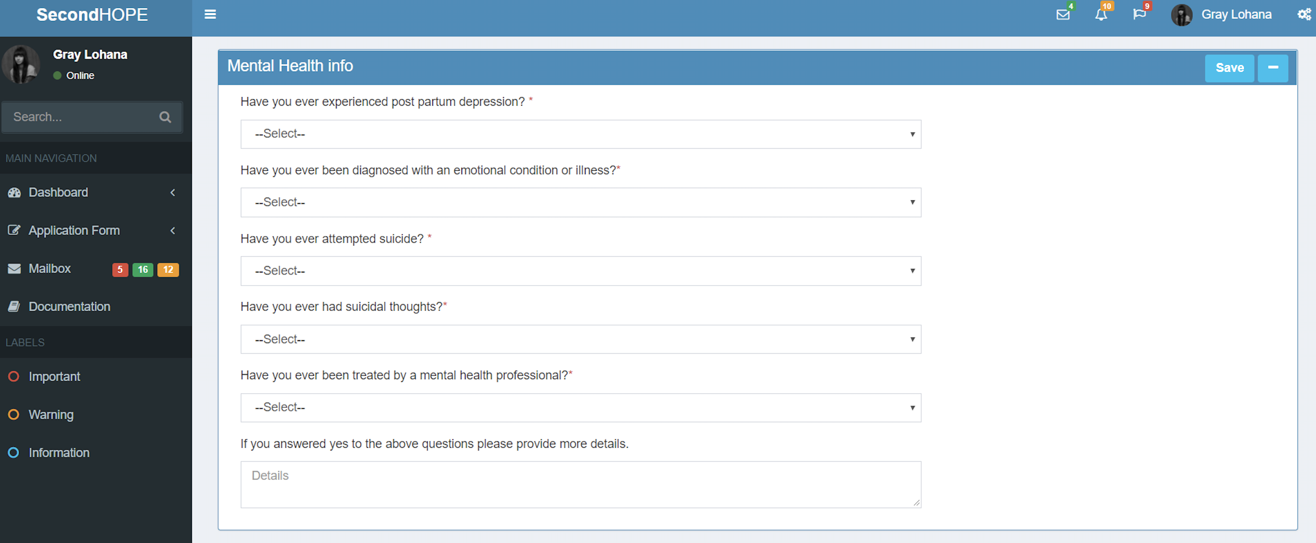

In this form, we have asked questions to see if the applicant is mentally stable in past and present.

**FOR CONNECTION STRING –**

For connection string need to refer web.config file and refer below code to connect with database

